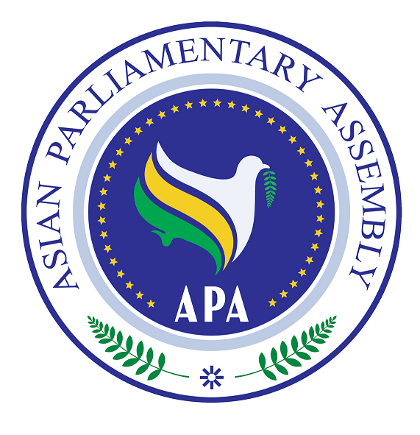

SG/Rep/2009/04
23 May 2009

The Report of

the APA Secretary-General

on

Challenges and Opportunities of Globalization in Asia

The Report of the APA Secretary-General on
Challenges and Opportunities of Globalization in Asia

Background

The first meeting of the Sub-Committee on Challenges and Opportunities of Globalization in Asia was held on 6 October 2008 in Tehran and considered the report of the Secretary-General and adopted its Report including the resolution to be submitted to the Executive Council. (APA/EC1/2008) The Executive Council met on 8-9 October 2008 in Tehran and approved the Report of the Sub-Committee. The Third APA Plenary met on 27-29 November 2008 in Jakarta and approved the resolution on Challenges and opportunities of Globalization in Asia. (APA/Res/2008/19)

Introduction

The resolution decided to mandate the Sub-Committee to continue to work. It further decided to establish a networking relationship between APA and major institutions dealing with globalization impact in each Asian country. The resolution requested the Secretary General to provide detailed explanation on the possible establishment of an “Asian Virtual Parliament” in order to facilitate and enhance debates and deliberation in an easy and prompt way. It also requested the Secretary-General to prepare a report for consideration of the Sub-Committee.

On 21 April 2009, in accordance with the Operative paragraphs 2, 5, 7 and 9 of the Resolution each requests either some reports or guidance from Member Parliaments to be forwarded to the Secretariat so as to enable the Secretary-General to prepare his report for consideration of the Sub-Committee, the Secretary-General communicated and consulted with Member Parliaments seeking their views on the implementation of the above-mentioned resolution. Those areas of interest would include: the feasibility of establishing an “ Asian Virtual Parliament “, to develop and promote adoption of a common legislation among member parliaments on the most important and less controversial aspects of globalization, to facilitate the exchange of information and data among APA parliaments with respect to the impact of globalization.

The impact of Globalization

Globalization has brought in a new era of interdependent human relations and culture. These interconnected processes have transformed human interactions at all local, national, regional and global levels. No sphere of human life is unaffected by such a global trend. In economy it has its impact on market, trade, export and import, employment and labor, investment and finance. Such global process has mainly resulted in marginalization of developing countries, widening the gap between poor and rich, as well as undermining sustainable development.

In social and cultural fields it has changed the shape of human society from individual life style to massive popular art industry. Global culture strongly undermines the social and cultural identity of different communities and weakens the traditional social institutions such as family, education. Cultural goods and services such as film, music, art crafts, painting, sculpture and architecture all are – to a broad extent under influence of globalization.

In the field of Communication the greatest transformation has revolutionized the whole world. Information technology has connected all corners of world together for almost all population. The same is true for media networks that through satellites and cyber technology have shaped the deed and mind of people all around the globe. Global networking and international actors either governmental or none governmental are playing unprecedented roles beyond traditional Nation-State boundaries.

The present Report is submitted to the Sub-Committee for its consideration on two major issues:

- On Common Legislation

There are significant areas with regard to globalization that may be helpful if a common legislation could be elaborated within the APA.

  - The impact of global financial systems in Asia, this initially requires exchange of experiences and information on major financial and currency problems to prevent or rectify the situation that drastically affects living conditions of Asian people. In particular, those developing countries which are most affected by this crises have the least ability to influence the global policies. The Secretary General emphasizes on the need for more effective and credible regulations to ensure global transparency and enforceable monitoring mechanism of the financial system. Such regulations should be applicable on all economic actors such as financial institutions, credit rating agencies, and audit firms. APA requires adopting a common approach toward such financial systems at national, regional and global levels. The role of Asian Parliaments in addressing global impact of current financial system on economy and society of Asian countries is of outmost importance.

- At the age of globalization, access to information technology is of vital significance in dealing with rapid structural and digital developments. This necessitates taking practical steps to narrow the digital divide among Asian countries as well as Asia and the World. Coordination and collaboration among APA members and exchanging data and information in the fields of information technology is regarded as the primary steps. To share best practices in order to benefit from each other’s experiences in overcoming digital gap is an imperative. Establishing a networking relationship at national and continental levels would enable parliaments to better coordinate to adopt common plan for addressing digital divide. Thus, the Secretary General suggests to the Sub-Committee to study and review the possibility of drafting a common legislation on Narrowing Digital Divide in Asia.

II_- The Virtual Asian Parliamentary Assembly (APA)

Since APA’s vision is to integrate Asian nations and materialize the potential of this large continent, it is essential to prepare the grounds for further dialogue and exchange of views among Asian countries. Asia, being the largest continent with at least half of the world population, is comprised of different religious, cultural, ethnic and linguistic varieties, which thus requires cohesive and effective institutions to enhance integration among Asian nations. The Establishment of the virtual parliament can be an effective step towards addressing this essential need.

The virtual parliament is not to substitute the current activities of the APA, such as the Plenary, Executive Council, Standing Committees and Sub-Committees; rather it is designed to further enrich the APA’s deliberations in a continuous way in the intervals of Committee Meetings. In fact, taking advantage of information technology would provide better grounds for deliberations and discussions among APA’s members in a much easier, inexpensive and faster manner. In this way, APA’s deliberations will not be confined to scheduled meetings that take place in different countries, but will continue, according to a timetable, via video-conferencing among members in order to draft proposals for upcoming meetings.
Thus, the advantages of the Virtual Parliament can be summarized as follows:
- Prevents the discontinuation of deliberations, and facilitate dialogue by providing sufficient time and space for member’s participation.
- Creates good opportunity for APA members to propose new ideas and further develop them;
- Enriches the deliberations by addressing different dimensions of issues due to sufficient time and opportunity ;
- Taking advantage of the opinion of experts and advisors by inviting them to participate in e-debates.
- Provides opportunities for simultaneously addressing two or more topics by members if necessary.

This initiative is designed to create a communication infrastructure for APA’s members to enhance the communicative capacity of APA, and transform it into a more active and strong Asian institution. The video-conferencing system helps to bring APA’s members closer to each other and encourages discussion and promotes solidarity.
Video-conferencing can accomplish the following:
- Holding meetings using one’s laptop at any time or place;
- Face-to-face online meetings;
- Voting ability using a username and password;
- Automatic recording of the meetings for future references;
- Accessing the archive of meetings;
- Providing live interpretation services for the people attending the conference;
- Sharing information and the presentation screen among members during the conference;
- Chairing the meetings with a chair-secretary system;
- Coordination, and if necessary, chairing the meetings by the Secretariat;
10) The opportunity for holding several conferences with different members; preparing the grounds for bilateral as well as multilateral negotiation s among members;
10) The possibility to use other communication facilities, soft wares and systems.
By entering the video-conference system, users will be able to hear and see the rest of the present members and thus contribute to the conference. Using this system, one can share articles, documents and other relevant files with the other members.

One could also accompany a presentation with their speech at the conference. The text and documents could be displayed at the same time as the speaker is giving his or her speech. In addition, since the speaker can also see and hear the rest of the members, a cooperating atmosphere will be created.

If there is a need for voting, the present members would cast their vote, either publicly or confidentially—depending on the opinion of the director of the conference—by using the voting system. One of the fundamental advantages of the system is the ability to store and archive the meetings for future reference.

What is the video-conferencing system?
A video-conference is a set of interactive telecommunication technologies which allow two or more locations to interact via two-way video and audio transmissions simultaneously. Using this technology, users, who are far away from one another, will be able to experience each others voice and image in a live and real manner.

By using computer and entering username and password, this system allows the user to enter the conference and contribute to the meeting by video and audio. The webcam and microphone attached to one’s computer would send the user’s voice and image to the members present at the conference. When parties are unable to meet in one place; Video-conferencing is widely used for live conversations, sharing visual information and in international seminars and conferences. The proposed method will operate on one’s computer just by using a web-browser; it does not require the download of any software.

Economic Advantages:
Taking into consideration the above details about this system, we can summarize the economic advantages of this system as follows:
- Increase in the duration of discussions and dialogue among members;
- Increase in the output and efficiency of the meetings;
- Decrease of costs of the meetings and workshops;
- Decrease of time required to arrange committee meetings;
- Decrease the cost of the Secretariat.

Requirements:
To use this system, a computer, a webcam and a microphone are required. If there is more than one person behind a computer, video projection can be used to facilitate the procedure. The internet speed required to use this system is at least 128 kilobytes per second. A high internet speed can affect the quality of your experience. In addition, if necessary, fingerprint or PIN codes could be used as passwords for voting in the system.

Recommendations

- The Sub-Committee supports the idea to share best practices in dealing with globalization impact in Asia and further designing a networking relationship among major governmental and non-governmental institutions active in the field of globalization with the view to formulate a common strategy.

- The Sub-Committee takes into consideration the proposal of the Secretary General to concentrate on both “the Global Impact of Financial System" and “Narrowing Digital Divide in Asia” with the view to finally draft two separate common legislation to be forwarded to the Plenary for its deliberation and final adoption. The Secretary General through consultation with members will identify main ideas and share them with the Sub-Committee to facilitate its deliberations on drafting common legislation for these two important issues.

- The Sub-Committee welcomes the important report of the Secretary General on “The Virtual Asian Parliamentary Assembly” and requests him to further study the requirements for the implementation of this significant suggestion. It also requests the Secretary General to consult with Member Parliaments and seek their assistance to provide technical facilities and voluntary contribution for establishing the Virtual Parliament in order to support a sustainable communication among members and promote integration in Asia.

